**JOBSHEET PRAKTIK CLOUD**

NAMA : LENA SYAKILA

KELAS : XII TKJ A

NO.ABSEN : 22

**MEMBUAT VIRTUAL PRIVATE CLOUD (VPC) DENGAN KONFIGURASI PUBLIK DAN PRIVAT SUBNET DI AWS**

1. **Menggunakan OREGON**
2. Masuk ke AWS Console, Arahkan ke “VPC” > Yours VPC, Buat VPC baru, Create VPC > name tag diisi (22-VPC-Sakti), IPv4 CIRD : 1xx.0.0.0/16 (xx : diisi nomer absen peserta), jadi 122.0.0.0/16 > Create vpc

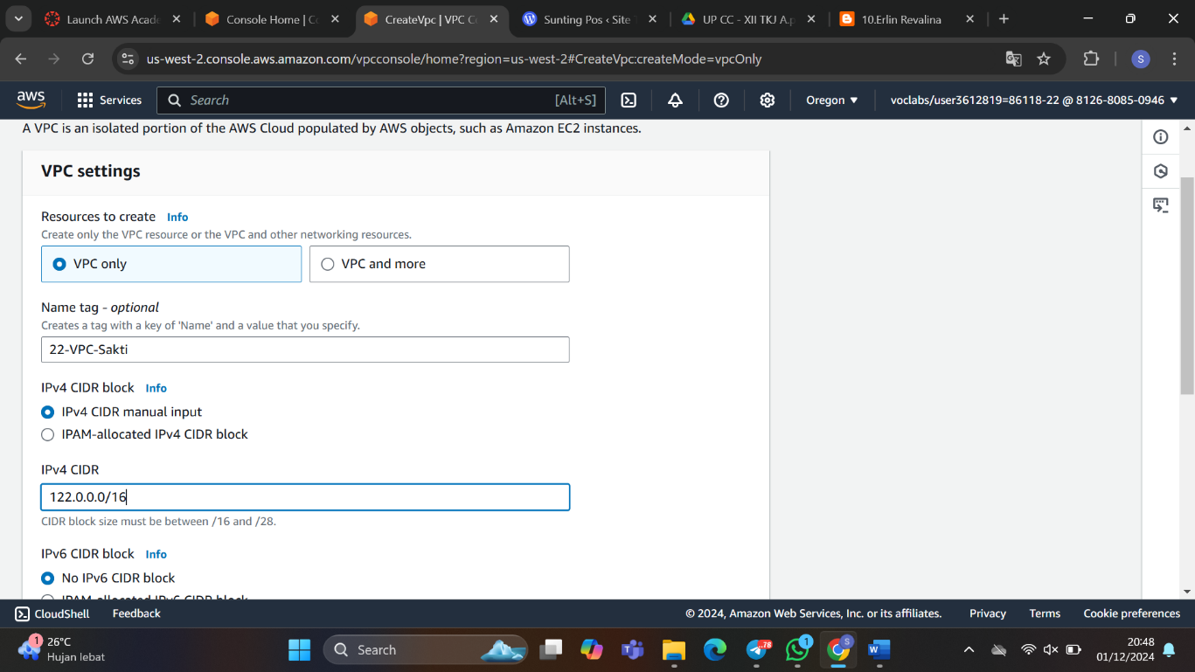

1. **Membuat Subnet**

Subnets > Create Subnet

Public Subnet

VPC ID : 22-VPC-Sakti > Subnet name diisi (22-Subnet-Public) > IPv4 subnet diisi (122.0.1.0/24)

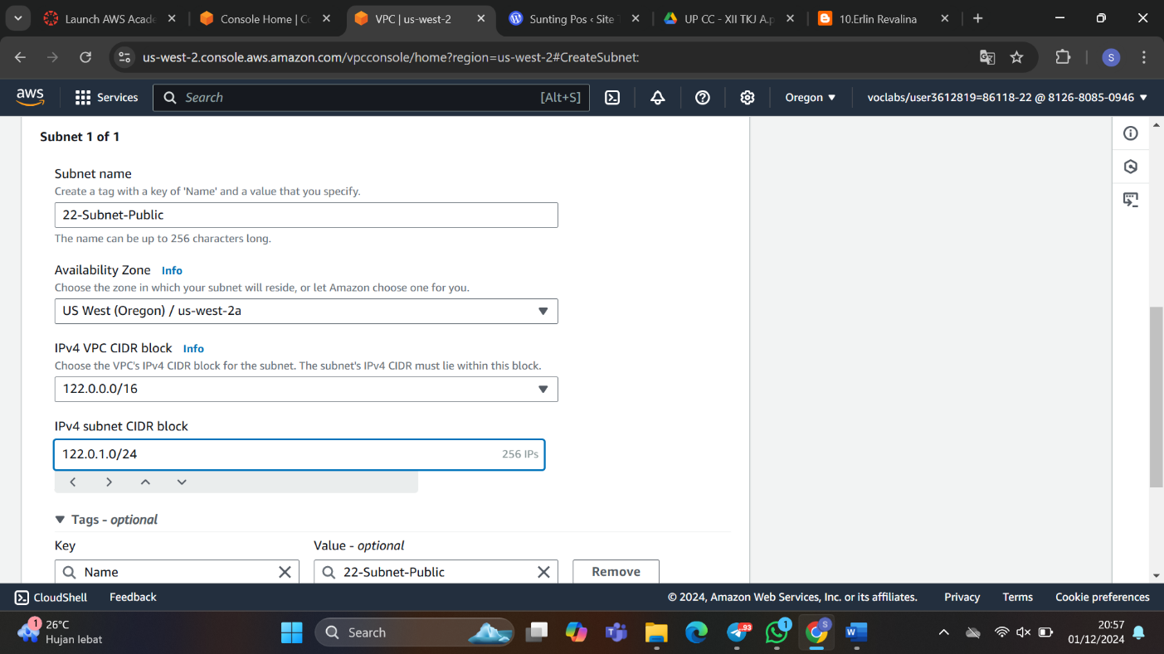

Privat Subnet

Subnet name diisi (22-Subnet-Privat) > IPv4 subnet diisi (122.0.2.0/24) > Create Subnet

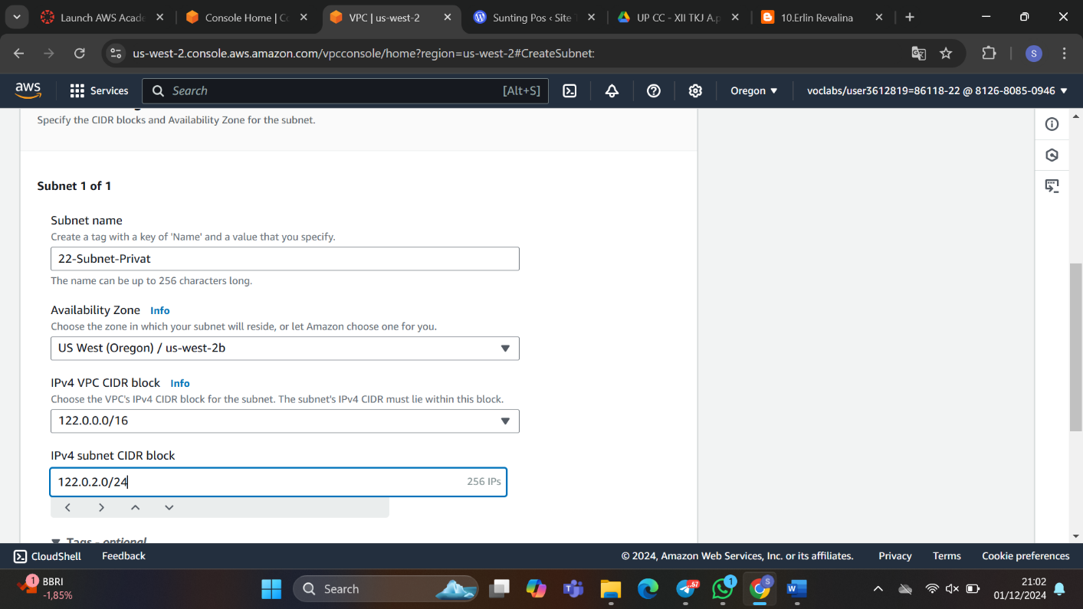

1. **Membuat Internet Gateway (IGW)**

Internet Gateway > Create Internet Gateway > name tag diisi (22-IGW-Sakti) > simpan

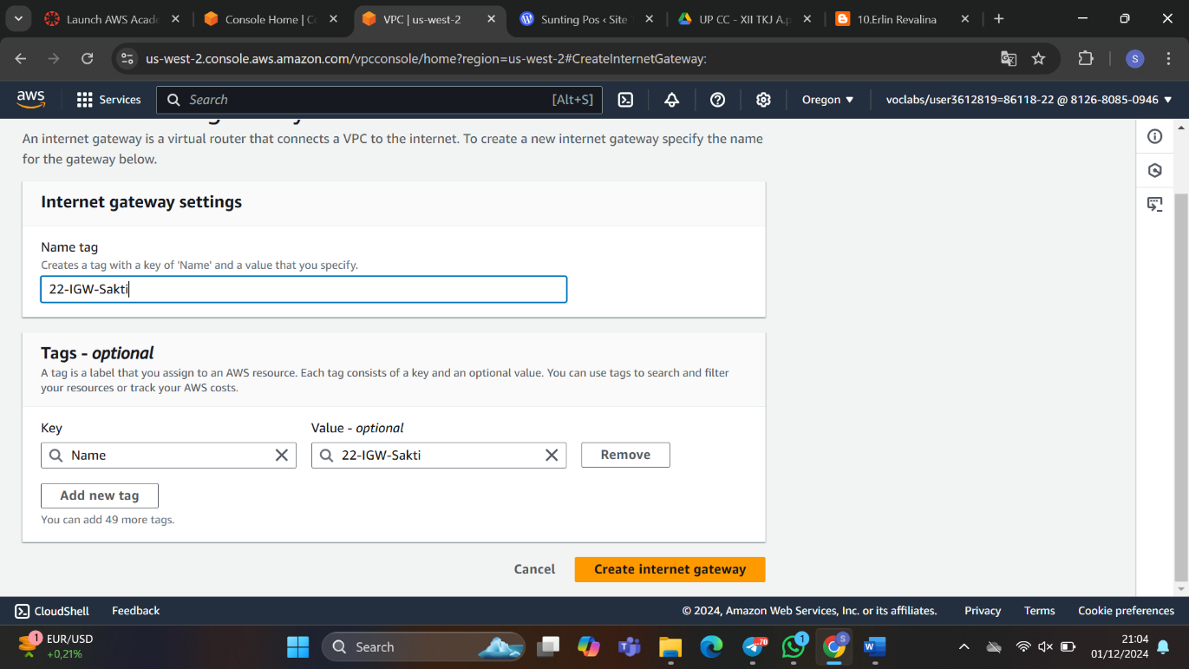

Attach to a VPC > Available VPCs : 22-VPC-Sakti > simpan

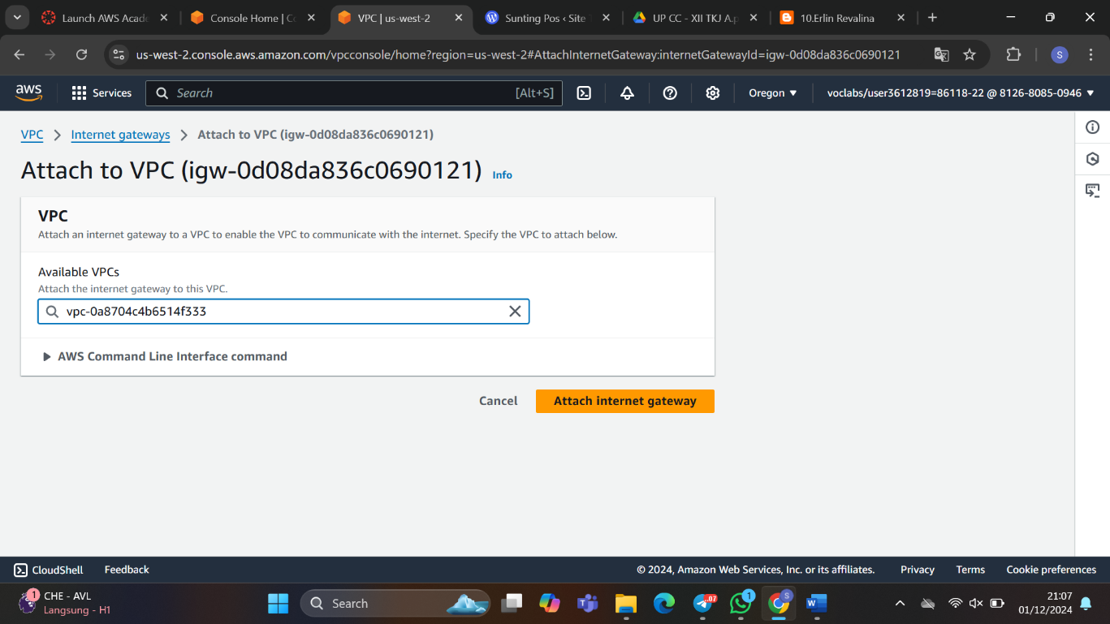

1. **Membuat Route Tables**

Buat 2 route table

Route Table > Create Route Table, Route Table Public, Nama diisi (22-RouteTable-Publik) > VPC (22-VPC-Sakti) > simpan

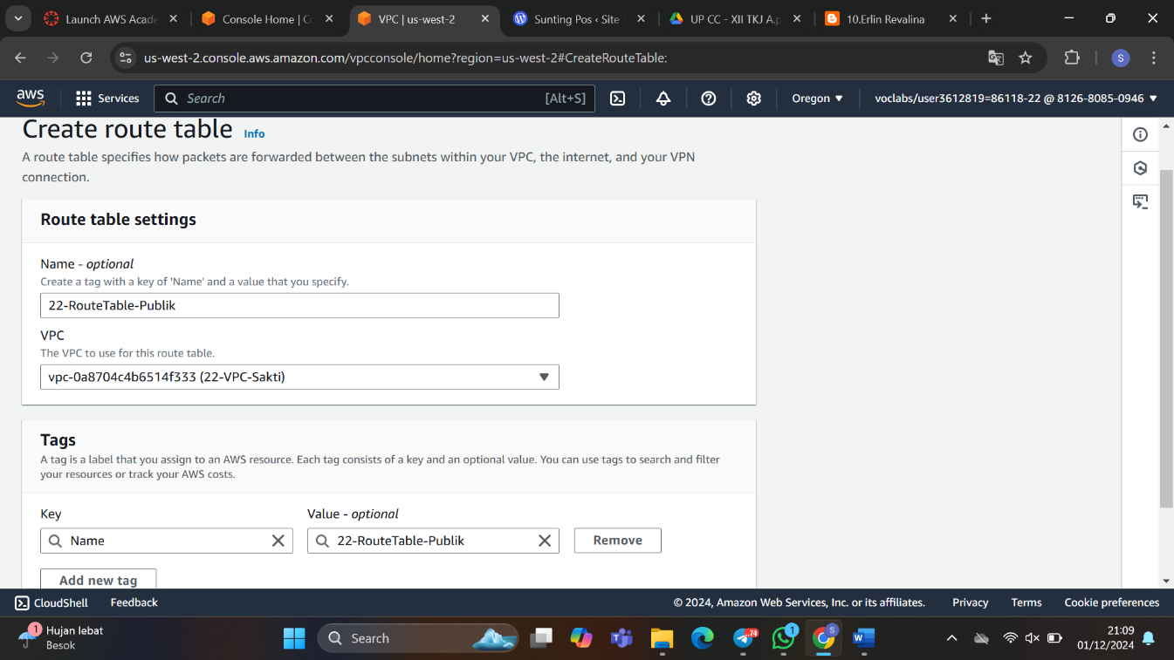

Route Table Privat

Nama diisi (22-RouteTable-Privat) > VPC (22-VPC-Sakti) > simpan

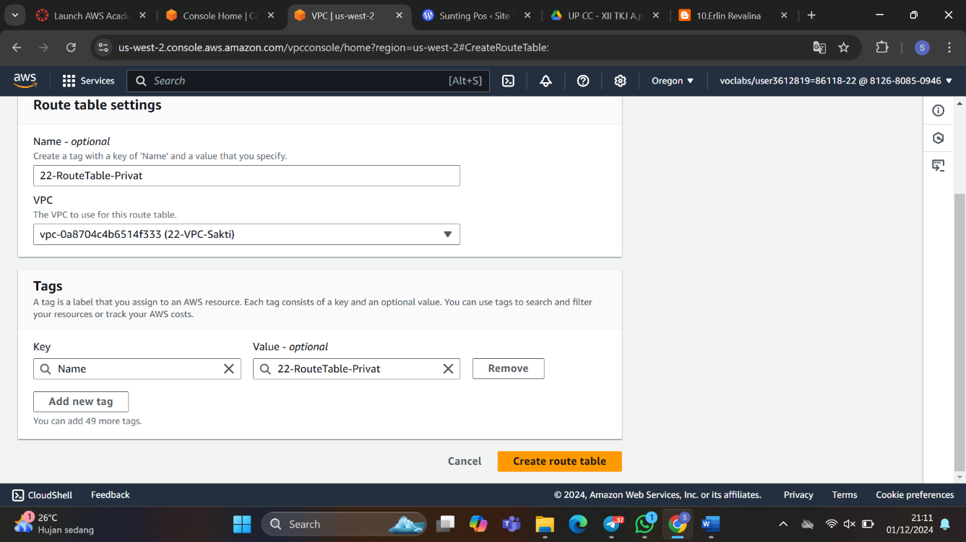

1. **Edit Routes Privat**

Add route > Destination 0.0.0.0/0 > Internet Gateway > igw : 22-IGW-Sakti > simpan

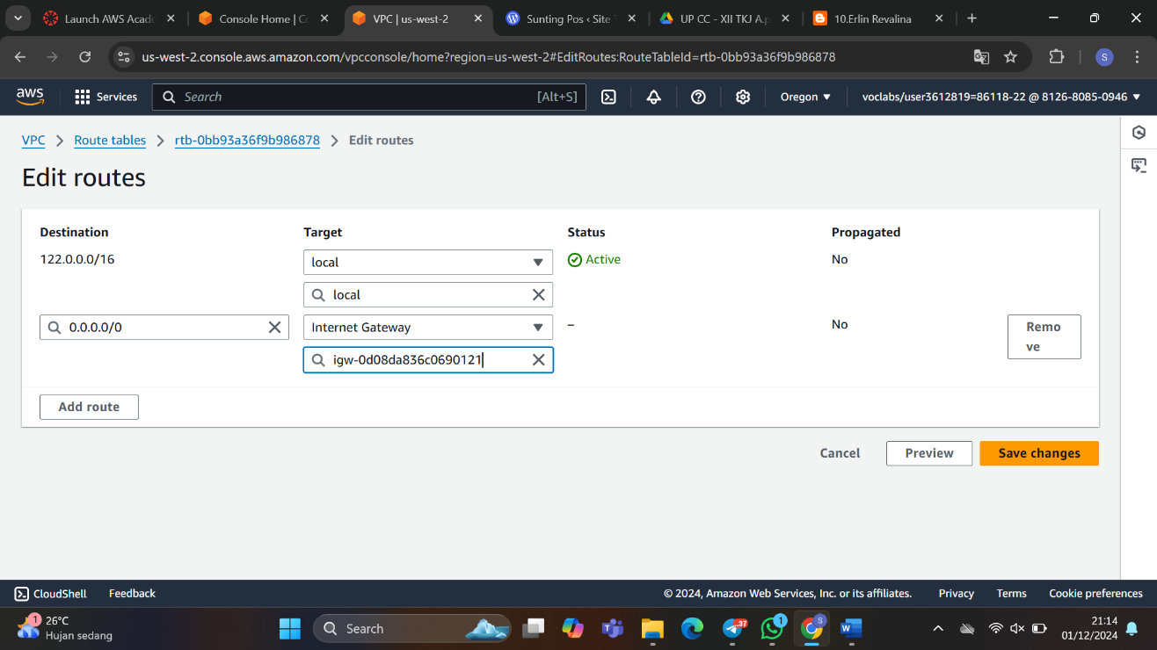

1. **Edit Routes Public**

Add route > Destination 0.0.0.0/0 > Internet Gateway > igw : 22-IGW-Sakti > simpan

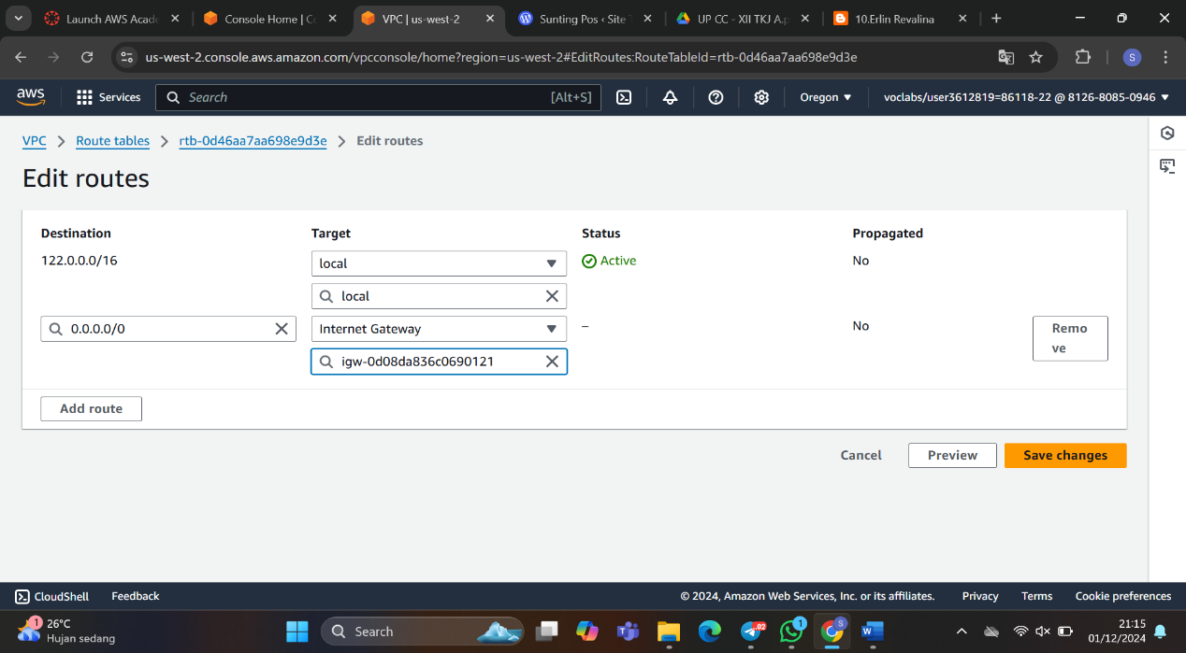

1. **Edit Subnet Associations Public**

Edit Subnet Associations > Klik 22-Subnet-Public > simpan

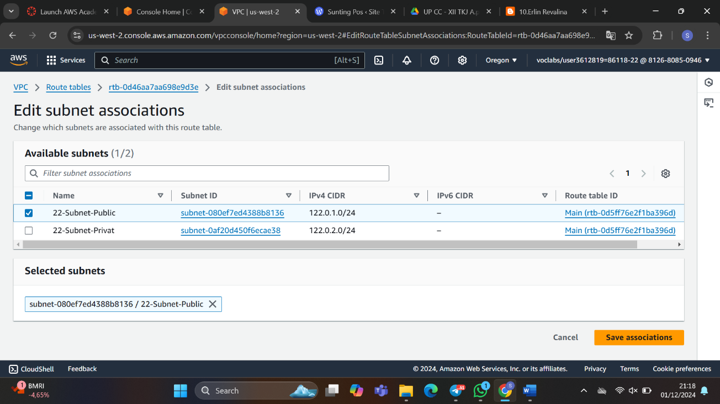

1. **Edit Subnet Associations Privat**

Edit Subnet Associations > Klik 22-Subnet-Privat > simpan

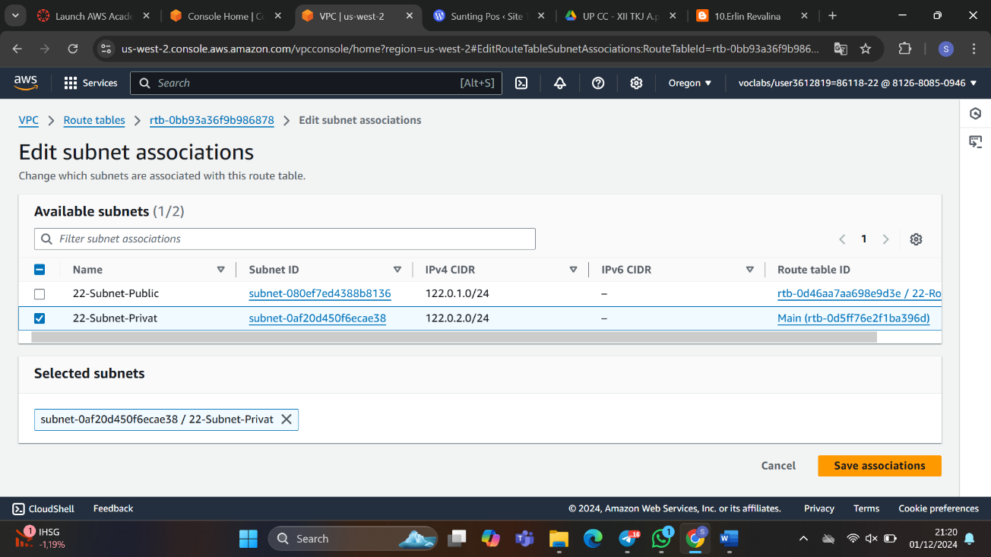

1. **Membuat Instance**

Public Instance

Launch Instance > Name diisi (22-WebServer) > dengan AMI AMAZON LINUX 2

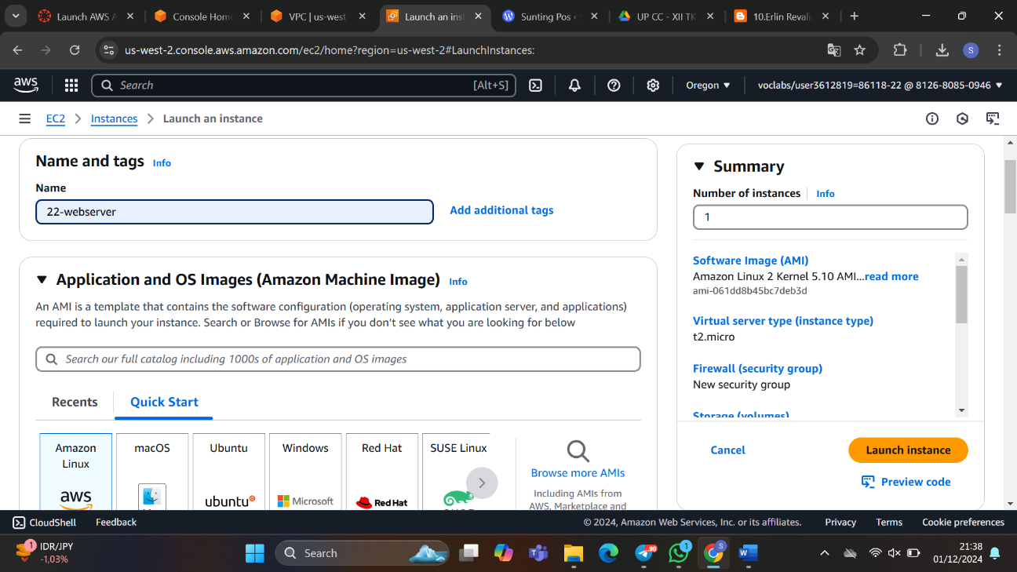

Key Pair Name diisi (keylunaaa) > vpc diganti 22-vpc-sakti > subnet diganti subnet public > simpan

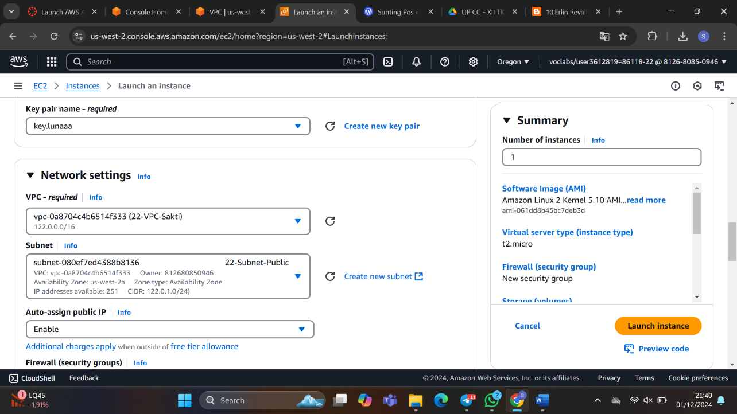

1. **Privat Instance**

Launch Instance > Name diisi (22-Database) > dengan AMI AMAZON LINUX 2

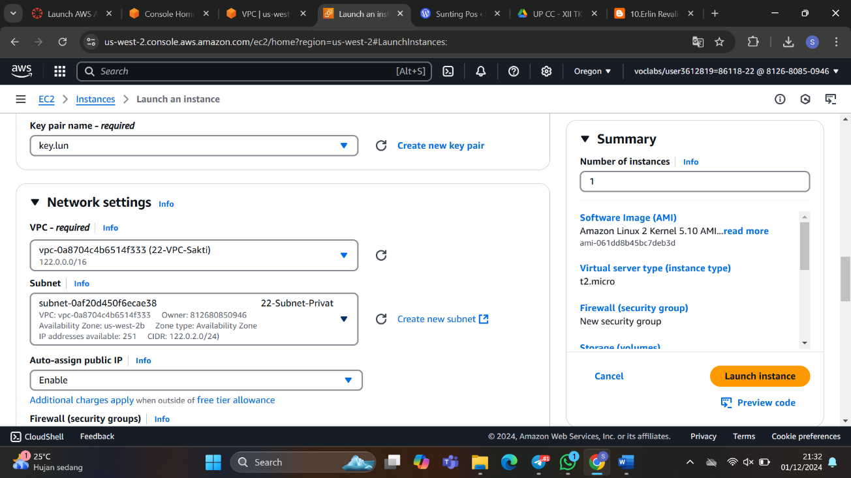

1. **Instalasi Web Server**

Klik 10-WebServer>klik connect>konfigurasikan:

# sudo su

# sudo yum install httpd -y

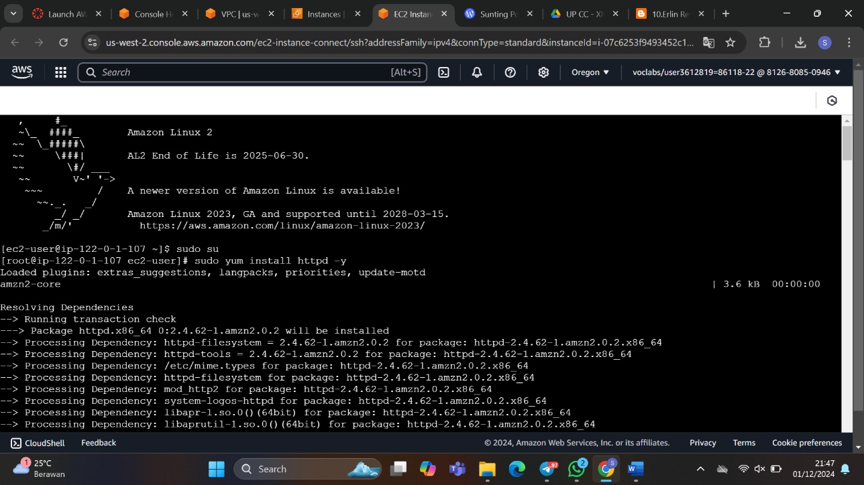

# sudo systemctl start httpd

# cd /var/www/html

# nano index.html

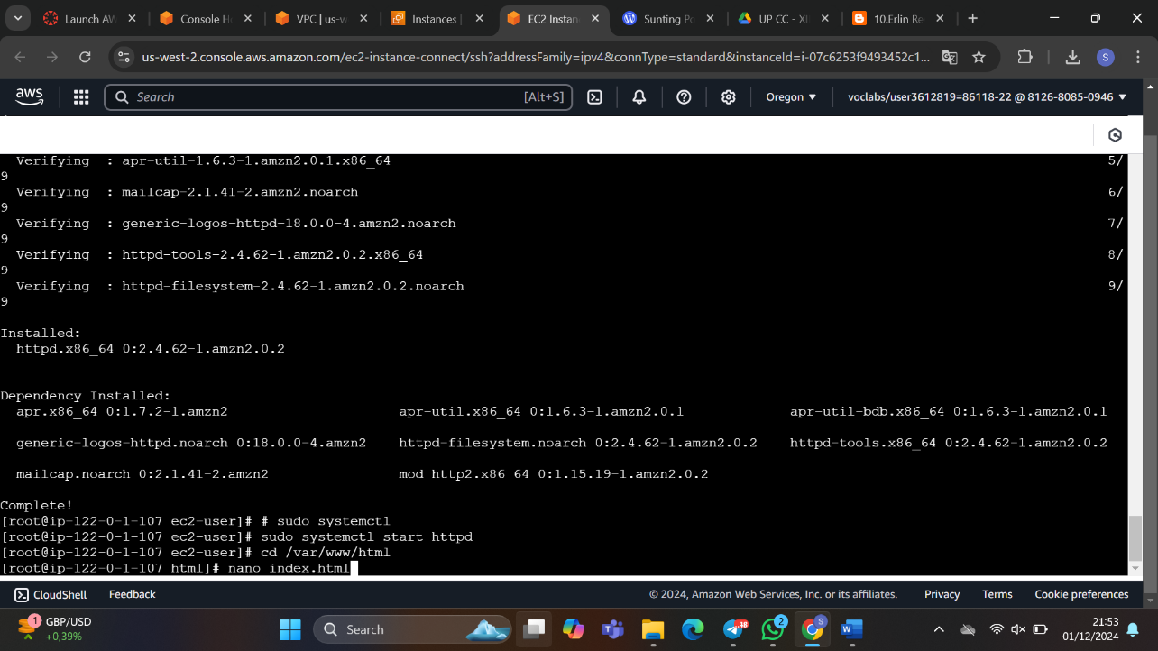

Isikan script biodata html

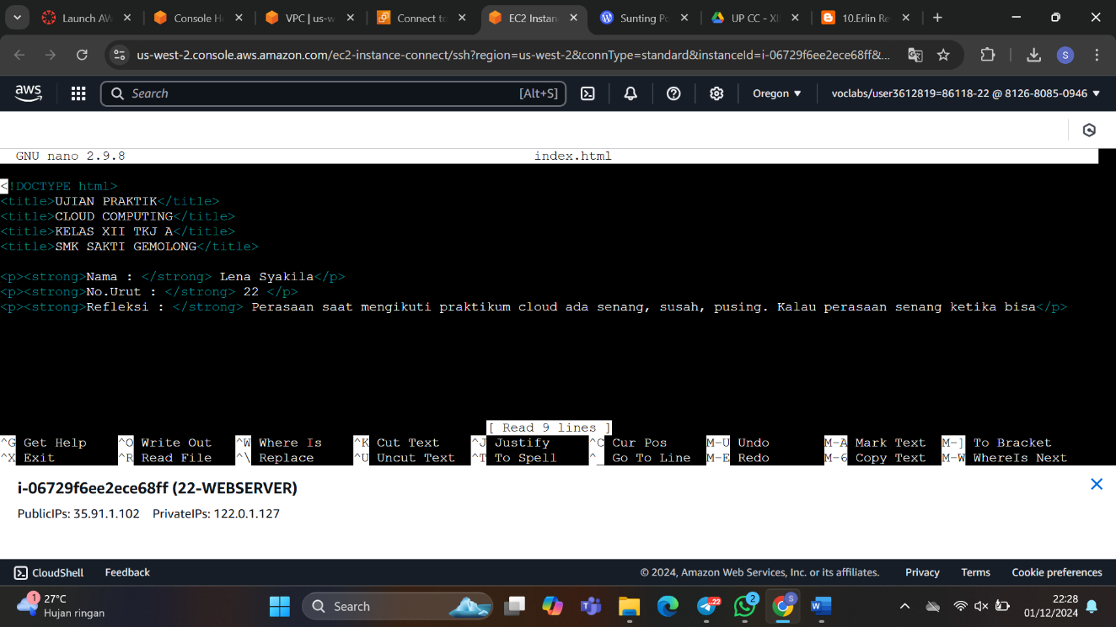

# copy IP public lalu paste di chrome sampai muncul web yang telah dikonfigurasi di index.html

**MEMBUAT RDS**

1. Membuat RDS

Buka RDS>klik RDS> create database>pilih MariaDB>pilih free tier>identitas beri nama (DBTekno-22)>master username (adminmaria)>  master password (Tekno!222024)> pilih VPC 22-VPC-Sakti> pubblic access (No)>availability zone uest a1

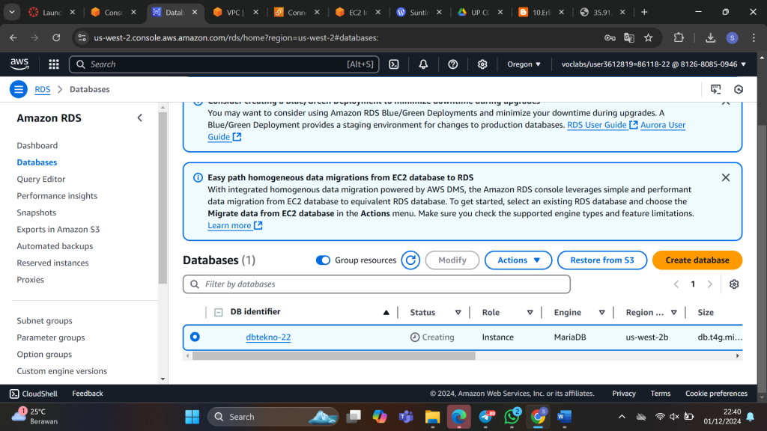

1. **membuat VPC**

klik Your VPC>create VPC> isikan nama 22-VPC-LabTekno

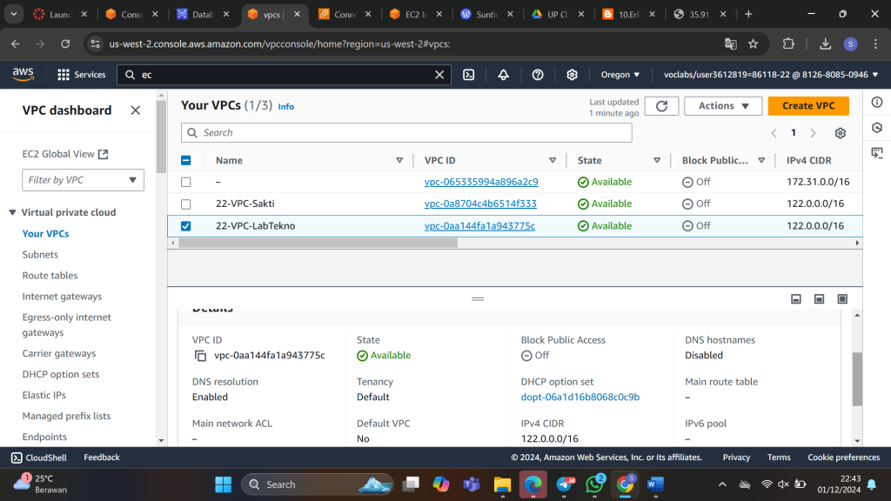

1. **Konfigurasi dengan RDS**

#sudo su

#sudo yum install mariadb105.x86_64

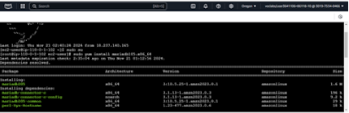

#mysql -h dbteknoo-10.c2dtjkzpr8s0.us-west-2.rds.amazonaws.com -u adminmaria -p

